Exhibit B: Creating a Traditional Document-by-Document Privilege Log

- Compiling the Log in Excel from Metadata Fields Exported from Review Platform

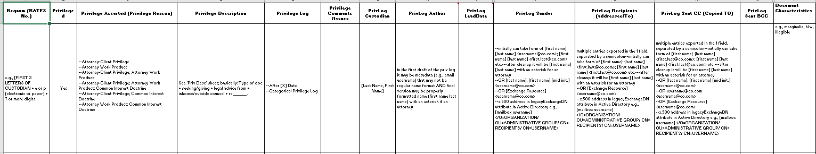

Privilege log Library: For corporations that have different matters involving same custodians over time, use of hash value to identify privileged files from other matters and add to privilege log in new matter. For example, if privilege documents were logged in matter “x” and the same custodian collected for matter “y,” use hash value to add privileged documents from matter “x” to matter “y” log without additional review work.

- Creating the Narrative Column for the Privilege log: Parsing out the Elements
*Note some example entries that begin with "house" should read "in-house."
